

*Project Title: Creation of an Application for School*



*Management – Admin*



**Presented By**

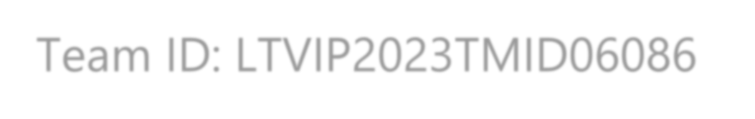

**Team ID: LTVIP2023TMID06114**

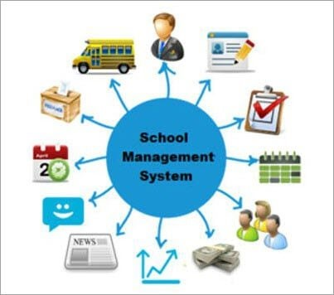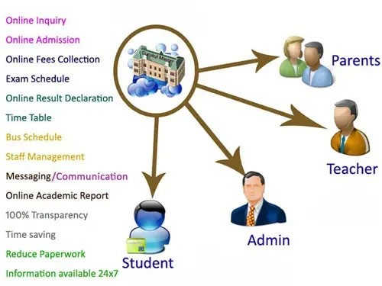

**TEAM DETAILS:**

**Team Leader: N.N.M.V SURYATEJA (**208x1a05f7@khitguntur.ac.in)

**Team Members:**

1. SHAIK ABZAL **(**208x1a0583@khitguntur.ac.in)
2. SHAIK ADILHUSSAIN **(**208x1a05h5@khitguntur.ac.in)
3. SHAIK NASEERUDDIN **(**208x1a05h8@khitguntur.ac.in)
4. SHAIK SAIDULLA **(**218x1a0518@khitguntur.ac.in)

# Our Trailblazer accounts

1. N.N.M.V SURYATEJA -<https://www.salesforce.com/trailblazer/s208x1a05f7>
2. SHAIK ABZAL -<https://www.salesforce.com/trailblazer/s208x1a0583>
3. SHAIK ADILHUSSAIN -https://www.salesforce.com/trailblazer/s208x1a05h5
4. SHAIK NASEERUDDIN -<https://www.salesforce.com/trailblazer/s208x1a05h8>
5. SHAIK SAIDULLA -<https://www.salesforce.com/trailblazer/s218x5a0518>

# Introduction

Salesforce is game-changing technology, with a host of productivity-boosting features, that will help you sell smarter and faster. As you work toward your badge for this module, we’ll take you through these features and answer the questions.

Salesforce is your customer success platform, designed to help you sell, service, market, analyze, and connect with your customers.

Salesforce has everything you need to run your business from anywhere. Using standard products and features, you can manage relationships with prospects and customers, collaborate and engage with employees and partners, and store your data securely in the cloud.

**Overview:**

A school management system is an information management system for educational institutions to manage student data. It helps teachers get information about students faster, easier and reduces their workload.

Student databases in school management systems contain information about the students, such as their exam grades, parent information, medical history, tuition fees, etc.

**Purpose:**

School management systems provide skills such as student registration, class documents, grades, analytical grades for students, and other assessment elements. In addition, school management systems are used to plan the curriculum of students, record their presence and manage the needs of students in the school.

School management solutions are web and mobile-based applications with centralized data storage structures that make it easier for administrators, students, teachers, and parents to access data from iPhone and Android devices

## LITERATURE SURVEY

**Existing Problems**:

* Inefficiencies: Manual processes are time-consuming and error-prone. Spreadsheets can be difficult to manage and update, and they can be easily corrupted. Disparate software systems can lead to data silos, which makes it difficult to get a complete picture of a student's academic record.
* **Data inconsistencies:** When data is stored in multiple systems, it is easy for it to become inconsistent. This can lead to inaccurate reports and decisions.
* **Communication gaps:** When there is no central communication platform, it can be difficult for teachers, parents, and administrators to communicate with each other. This can lead to misunderstandings and delays.
* **Increased costs:** Schools may need to hire more staff to handle administrative tasks, or they may need to invest in expensive software.
* **Reduced productivity:** Teachers and administrators may spend a significant amount of time on administrative tasks, which takes away from time they could be spending on teaching and learning.
* **Poor student outcomes:** When students' academic records are inaccurate or incomplete, it can make it difficult for them to get the help they need.
* **Dissatisfied parents and guardians:** Parents and guardians may be frustrated with the lack of communication from the school, or they may be concerned about the security of their child's data.

**Proposed Solution:**

* A comprehensive cloud-based school management application will be developed.
* The application will have an intuitive interface, automation features, and seamless integration.
* It will facilitate efficient attendance tracking, academic management, and communication among teachers, parents, students, and administrators.
* The application will provide valuable insights through analytics and reports, ensuring data-driven decisionmaking.
* The application will have robust security measures and customization options, allowing schools to enhance overall efficiency and productivity, creating a more streamlined and effective learning environment.

Overall, the proposed solution is a comprehensive and innovative approach to school management. It has the potential to significantly improve the efficiency, productivity, and effectiveness of school operations.

## THEORITICAL ANALYSIS

**Process Diagram:**

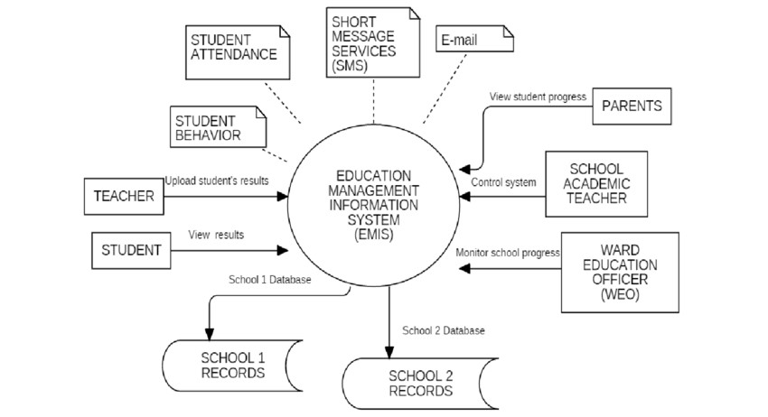

**Hardware and Software Designing:**

In the Salesforce platform, the School Management Application would be developed as a cloud-based software solution, which means most of the hardware requirements would be taken care of by Salesforce itself. However, there are still some essential hardware and general requirements to consider:

### 1.Hardware Requirements

The following hardware requirements are essential for running the School Management Application on the Salesforce platform:

* A computer with a minimum of 4GB of RAM and 20GB of free disk space.
* A web browser that supports HTML5 and JavaScript.
* A reliable internet connection

### 2.Salesforce Platform Requirements

* Salesforce Account
* Edition
* Licenses

### 3.Salesforce Limits and Allocations

* API Limits
* Data Storage
* Custom Objects and Fields

### 4.Security and Compliance

* Data Privacy
* User Authentication

### 5.Customization and Development

* Development Environment
* Integration Requirements

### 6.User Training and Support

* User Training
* Technical Support

## PROCESS AND RESULTS

**1.Creating Developer Org:**

Creating a developer org in salesforce

* Go to [developer.salesforce.com](https://developer.salesforce.com/)
* Click on sign up.
* On the signup form, enter the following details
* First name & Last name
* Email
* Role – Administrator
* Company - College Name
* Country – India
* Postal Code - pin code 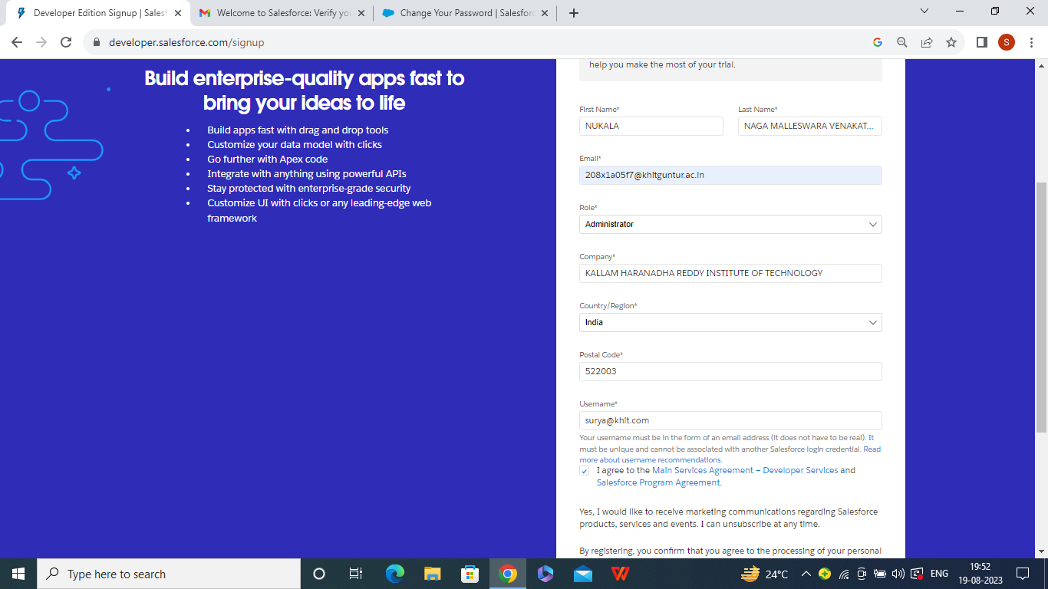

Username- should be a combination of your name and company

**Account Activation:**

Go to the inbox of the email that you used while signing up. Click on the verify account to activate your account. The email may take 5-10mins, as

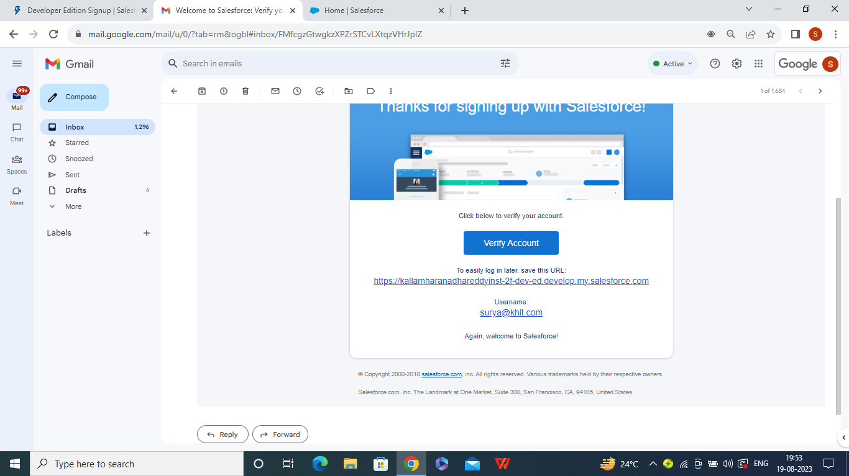

**Login To Your Salesforce Account**

* Go to salesforce.com and click on login.
* Enter the username and password that you just created.
* After login this is the home page which you will see.

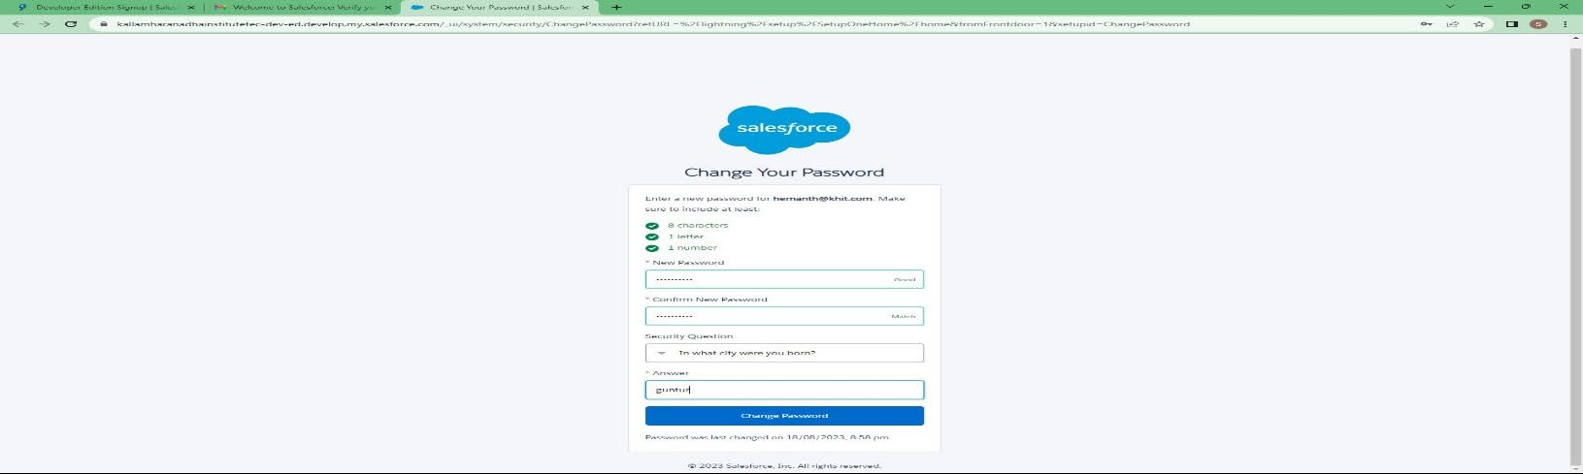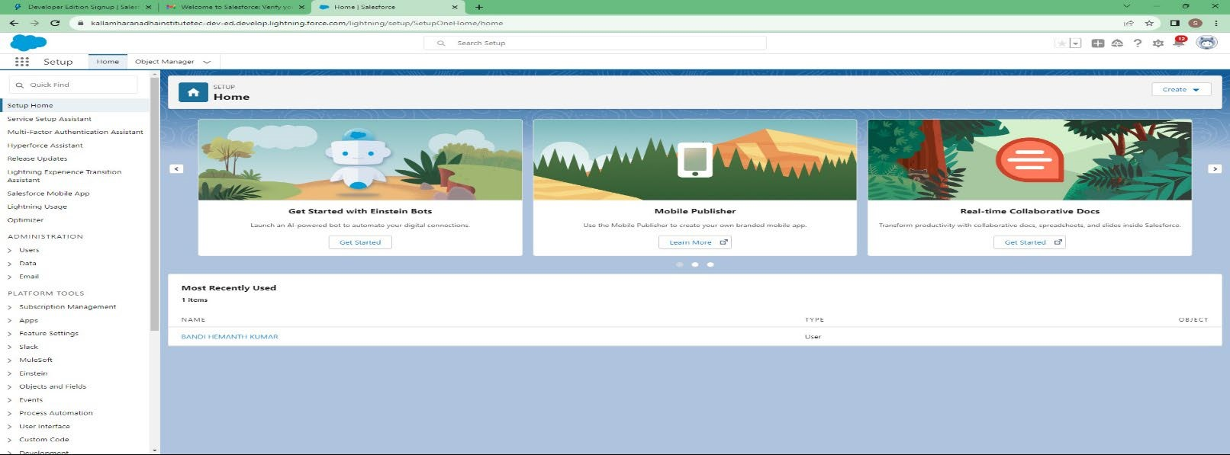

Here's a brief introduction to the key components of the Salesforce setup page:

**1.Home:** The central hub for Salesforce administrators to access and manage all setup options.

**2.Object Manager:** Customize and manage standard and custom objects, defining data structure and relationships.

**3.App Launcher:** Easily switch between Salesforce apps and custom-built applications.

### Object

Salesforce objects are database tables that permit you to store data that is specific to an organization. Salesforce objects are of two types: Standard Objects: Standard objects are the kind of objects that are provided by salesforce.com such as users, contracts, reports, dashboards, etc.

Salesforce objects are of two types:

* Standard Objects: Standard objects are the kind of objects that are provided by salesforce.com such as users, contracts, reports, dashboards, etc.
* Custom Objects: Custom objects are those objects that are created by users. They supply information that is unique and essential to their organization. They are the heart of any application and provide a structure for sharing data.

### Creation Of School Object Creation of Objects for School Management

For this school management we need to create 3 objects School, Parents and Student. The below steps will assist you in creating those objects.

1. Click on the gear icon and then select Setup.
2. Click on the object manager tab just beside the home tab.
3. After the above steps, have a look on the extreme right you will find a Create Dropdown click on that and select Custom Object.
4. On the Custom Object Definition page, create the object as follows:
5. Label: School
6. Plural Label: Schools
7. Record Name: School Name
8. Check the Allow Reports checkbox 9. Check the Allow Search checkbox 10. Click Save.

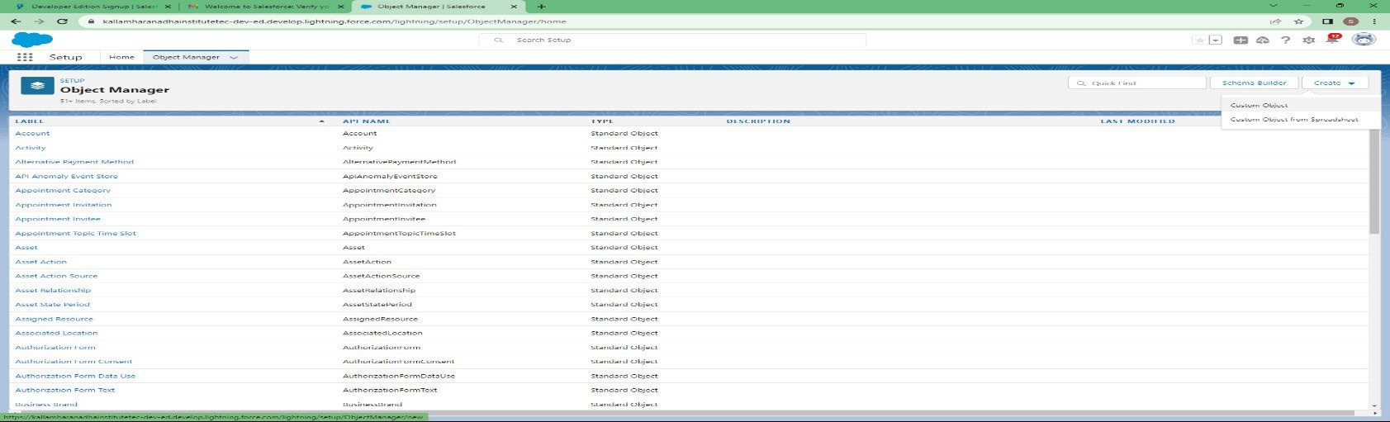

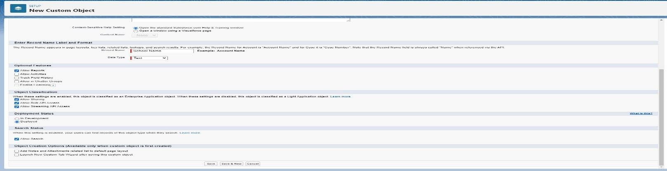

Now create a custom tab. Click the Home tab.

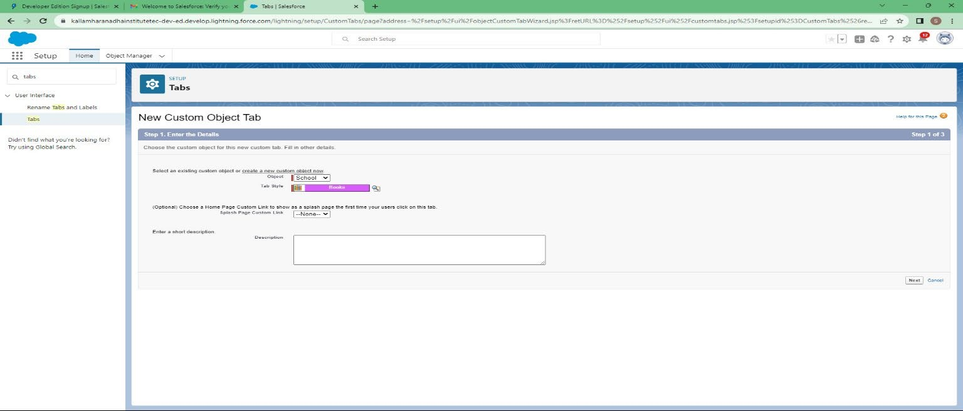

### Create Student Object

1. Click on the gear icon and then select Setup.
2. Click on the object manager tab just beside the home tab
3. After the above steps, have a look on the extreme right you will find a Create Dropdown click on that and select Custom Object.

* On the Custom Object Definition page, create the object as follows: • Label: Student
* Plural Label: Students
* Record Name: Student Name
* Check the Allow Reports checkbox • Check the Allow Search checkbox • Click Save.

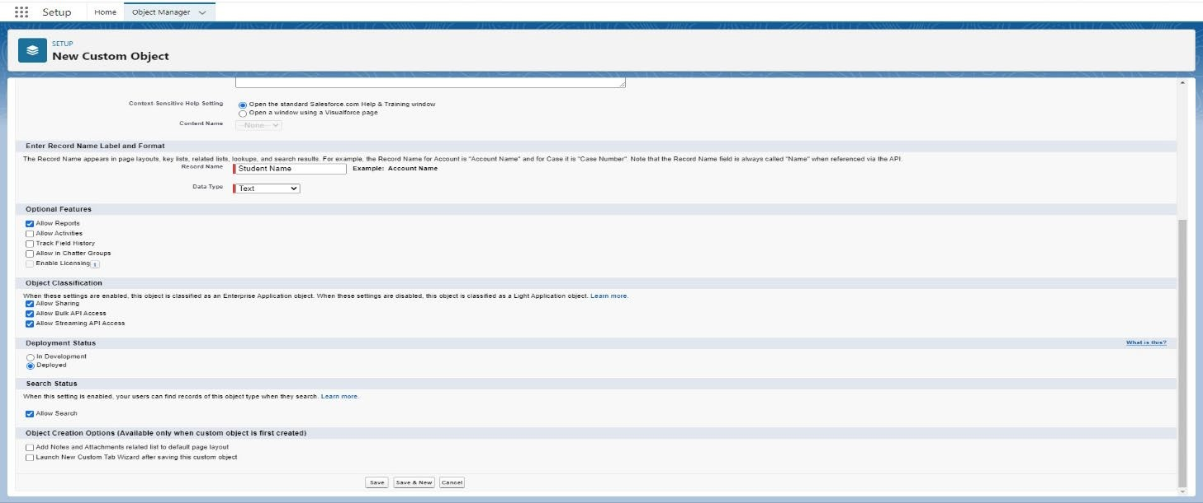

Now create a custom tab. Click the Home tab, enter Tabs in Quick Find and select Tabs. Under Custom Object Tabs, click New.

1. For Object, select Students.
2. For Tab Style, select any icon.
3. Leave all defaults as is. Click Next, Next, and Save.

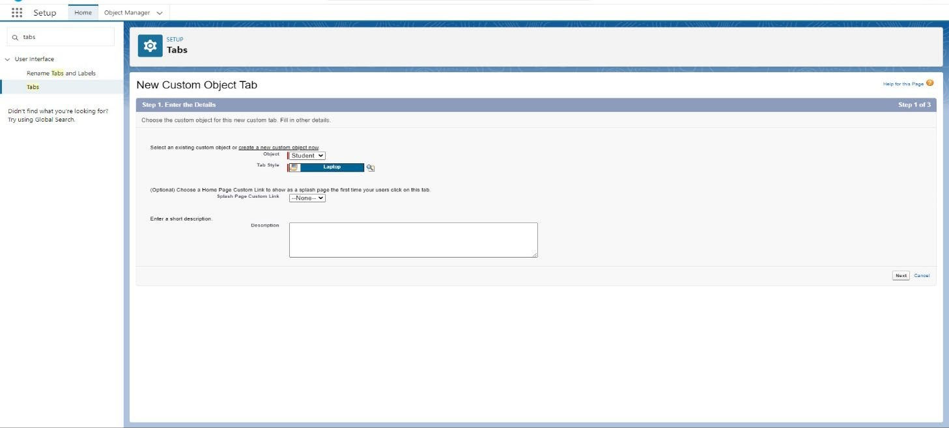

### Create Parent Object

Click on the gear icon and then select Setup.

1. Click on the object manager tab just beside the home tab.
2. After the above steps, have a look on the extreme right you will find a Create Dropdown click on that and select Custom Object.

* On the Custom Object Definition page, create the object as follows: • Label: Parent
* Plural Label: Parents
* Record Name: Parent Name
* Check the Allow Reports checkbox • Check the Allow Search checkbox • Click Save.

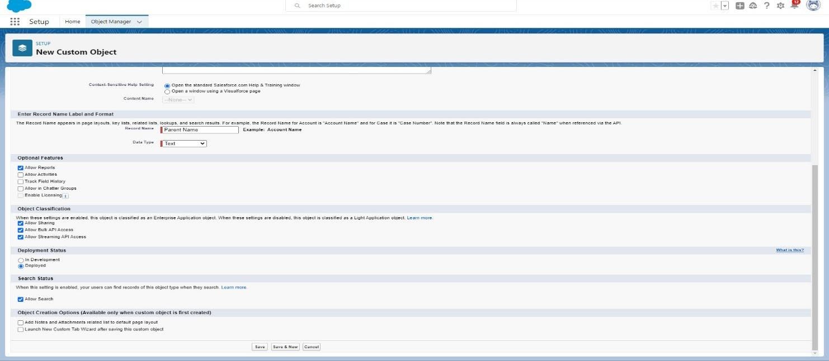

**Now create a custom tab. Click the Home tab, enter Tabs in Quick Find and select Tabs. Under Custom Object Tabs, click New.**

1. For Object, select Parents.
2. For Tab Style, select any icon.
3. Leave all defaults as is. Click Next, Next, and Save.

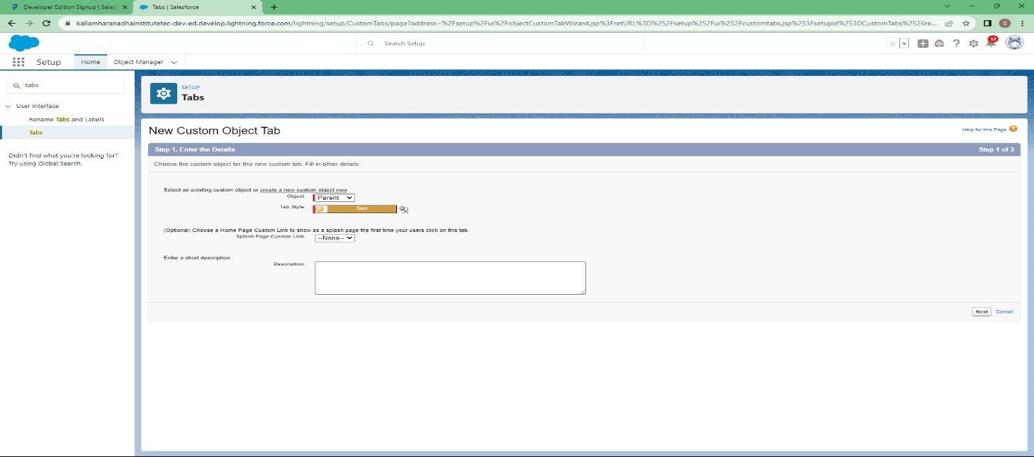

### Lightning App

* Apps in Salesforce are a group of tabs that help the application function by working together as a unit. It has a name, a logo, and a particular set of tabs. The simplest app usually has just two tabs. • There are two types of app -
* Standard App: Standard apps come with every occurrence of Salesforce as default. Many features like Sales, Marketing, Community, call center, content, Salesforce Chatter, App Launcher, etc are present in it.
* Note: The description, Logo, and Label of standard app cannot be altered.
* Custom Apps: Custom apps are created according to need of user. Custom Apps are made by using standard and custom tabs together.
* Note: Logos for Custom Apps can be changed.

### Create The School Management App

1.From Setup, enter App Manager in the Quick Find and select App Manager.

1. Click New Lightning App.
2. Enter School Management as the App Name, then click Next 4. Under App Options, leave the default selections and click Next.
3. Under Utility Items, leave as is and click Next.
4. From Available Items, select Schools, Students, Parents, Reports, and Dashboards and move them to Selected Items. Click Next.
5. From Available Profiles, select System Administrator and move it to Selected Profiles. Click Save & Finish.

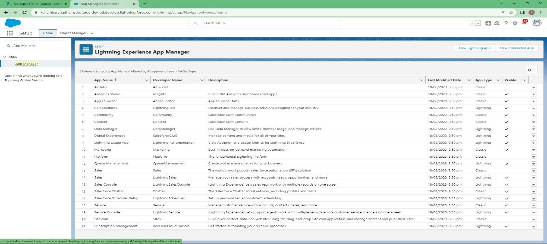

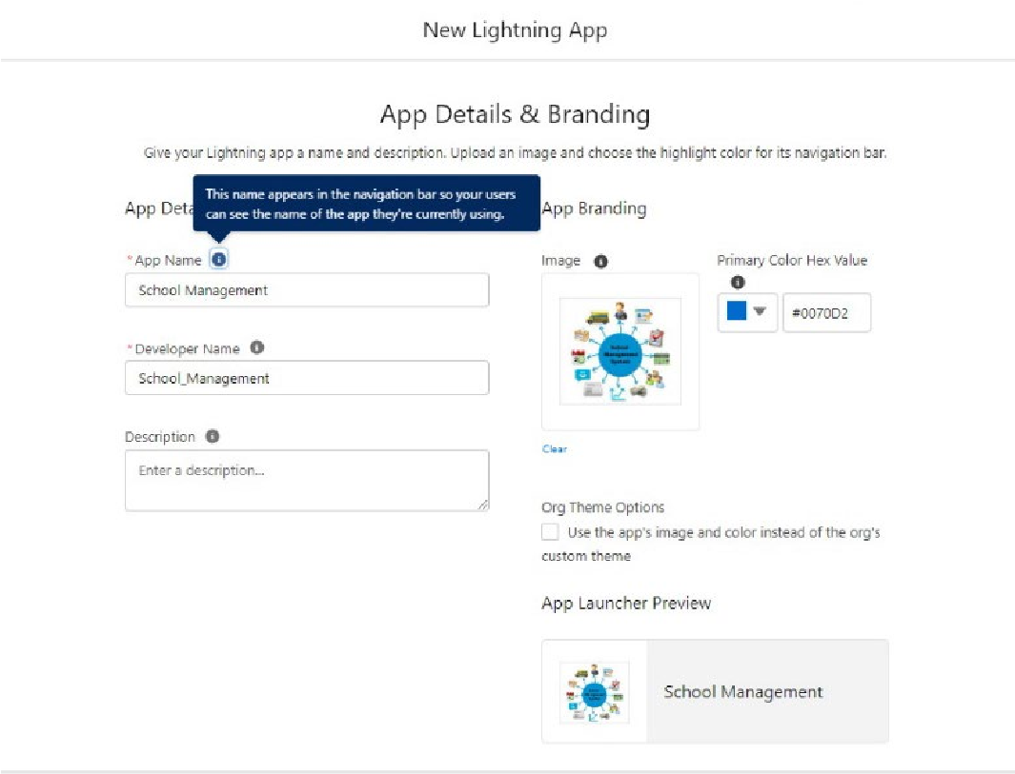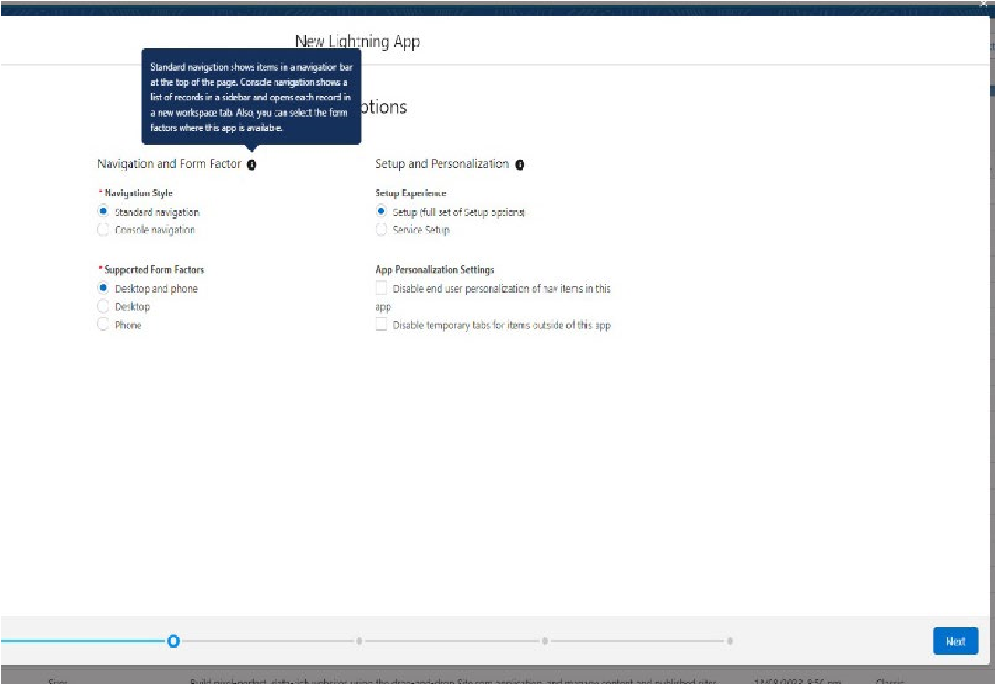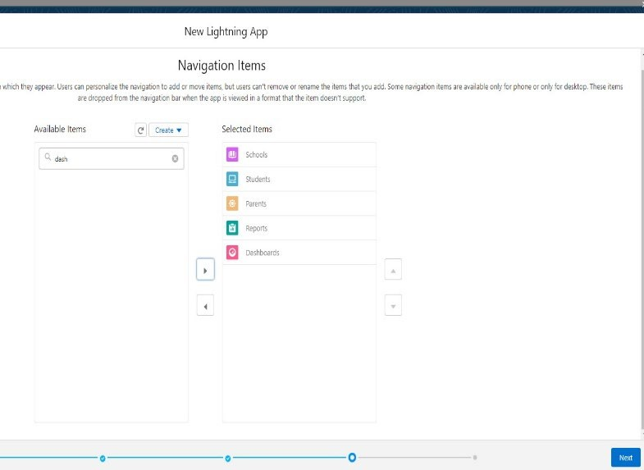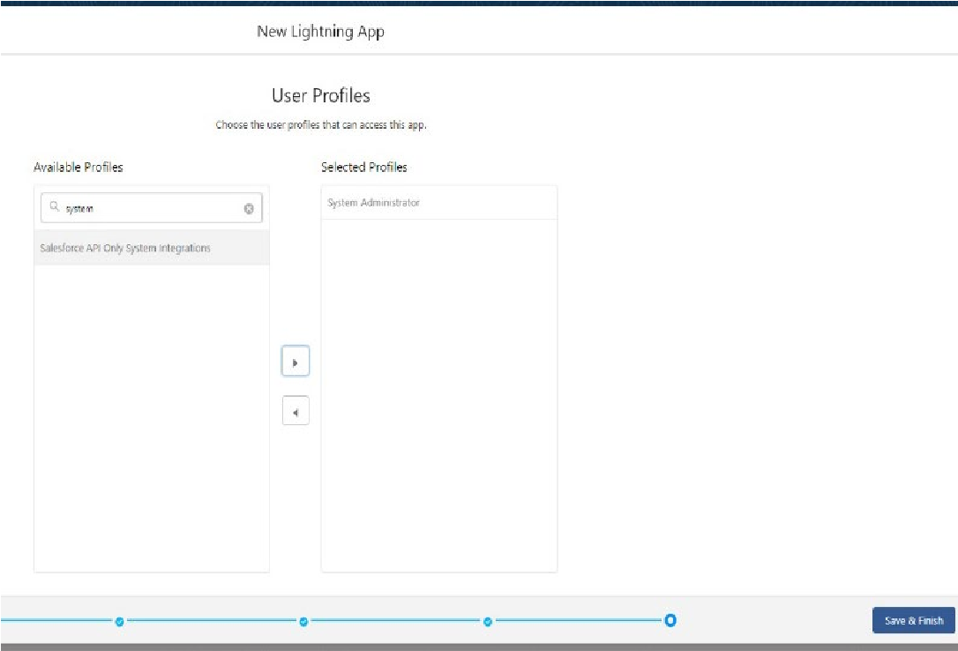

To verify your changes, click the App Launcher, type School Management and select the School Management app.

**Note:**

App Launcher-Displays available apps.

App Name-Displays the current selected app.

Navigation menu -Displays the tabs available inside the app.

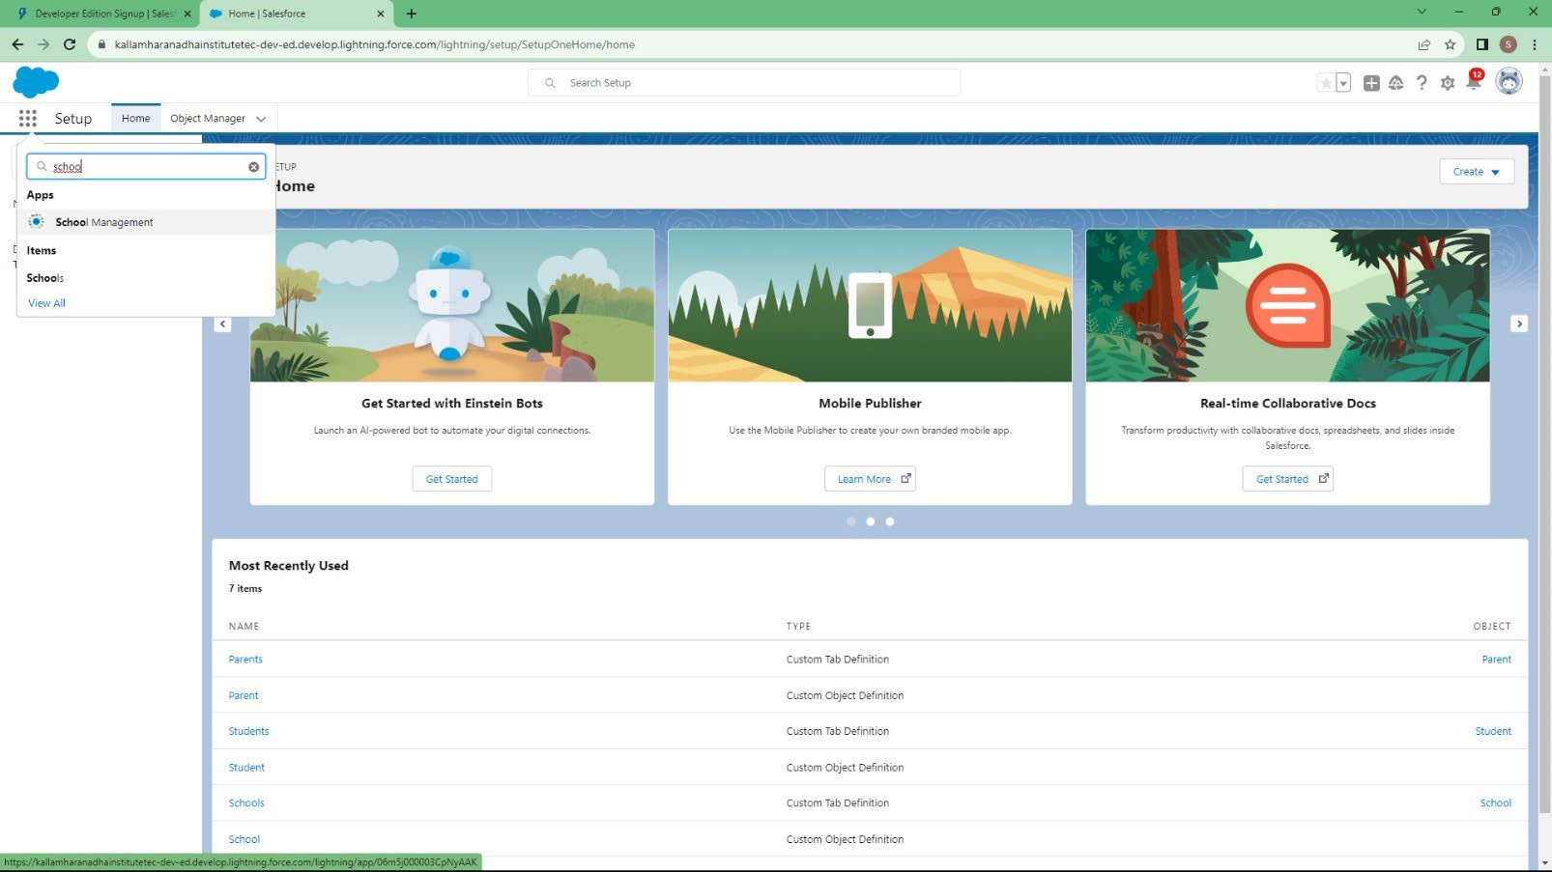

#### Fields And Relationship

An object relationship in Salesforce is a two-way association between two objects. Relationships are created by creating custom relationship fields on an object. This is done so that when users view records, they can also see and access related data.

#### Creation Of Fields For The School Objects

1. Click the gear icon and select Setup. This launches Setup in a new tab.
2. Click the Object Manager tab next to Home.
3. Select School.
4. Select Fields & Relationships from the left navigation
5. Click New
6. Select the Text Area as the Data Type, click Next.
7. For Field Label, enter Address.
8. Click Next, Next, then Save & New.
9. Follow steps 1 to 3 and create two more Text type field - District & State.
10. Create URL type field & give School website as the field label.

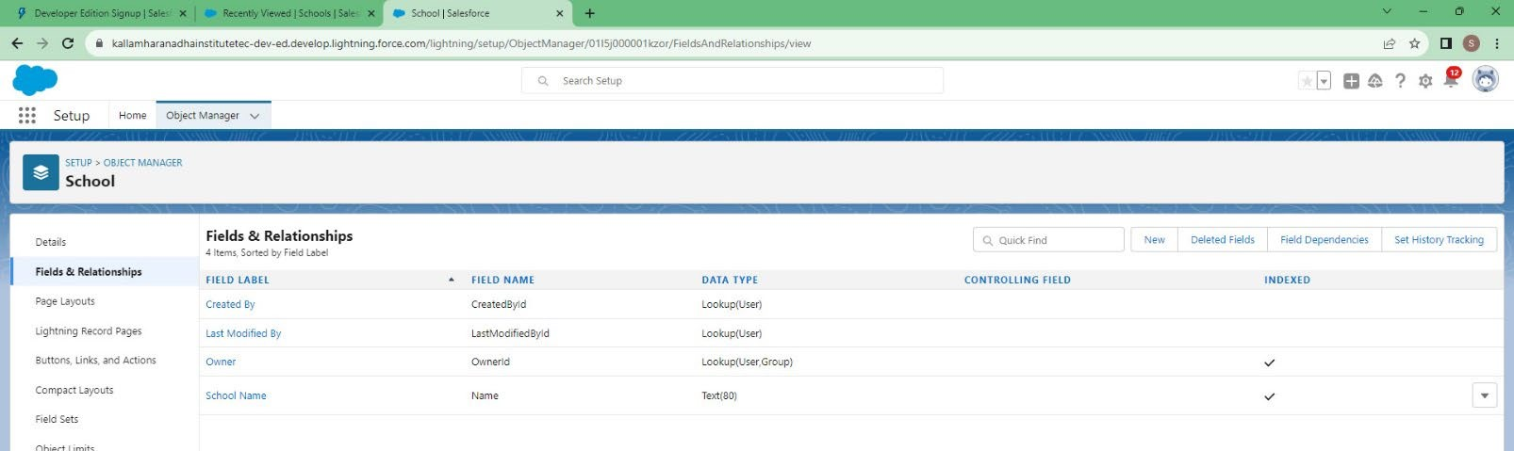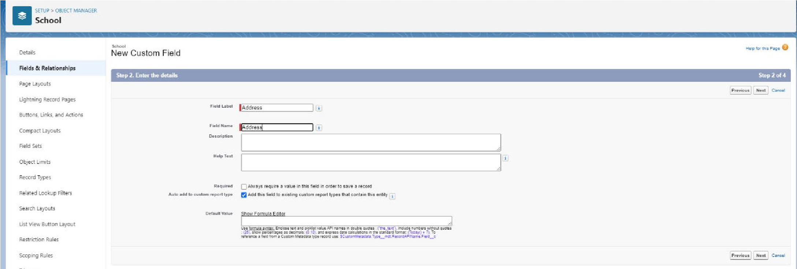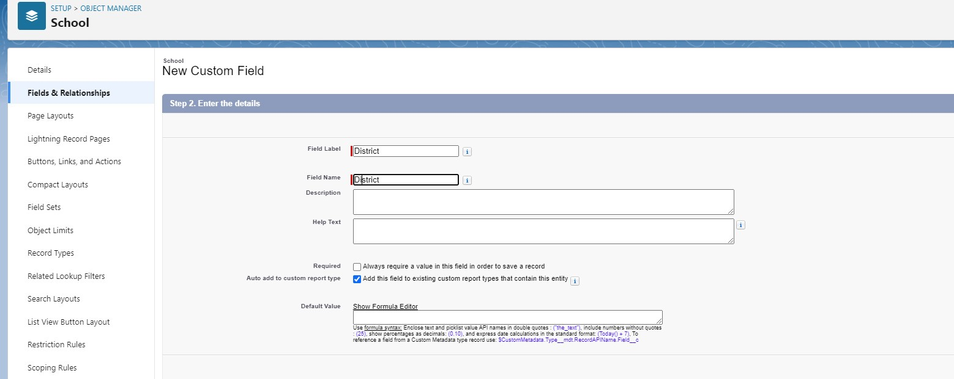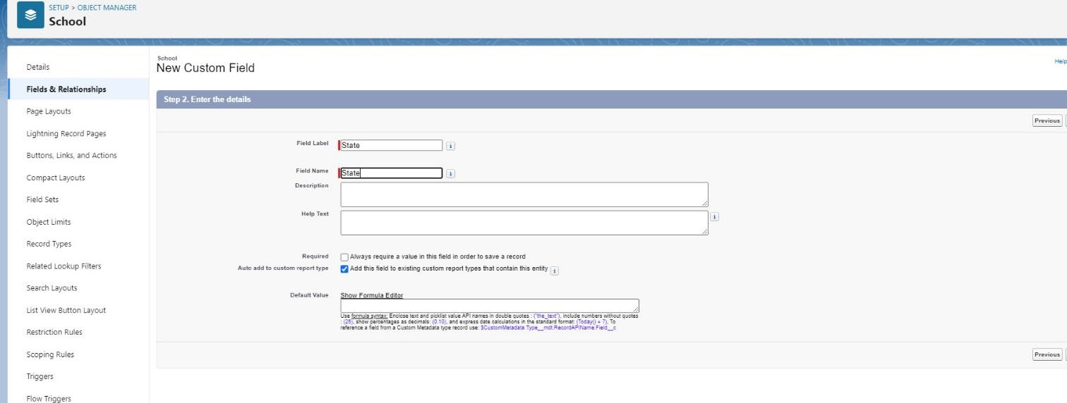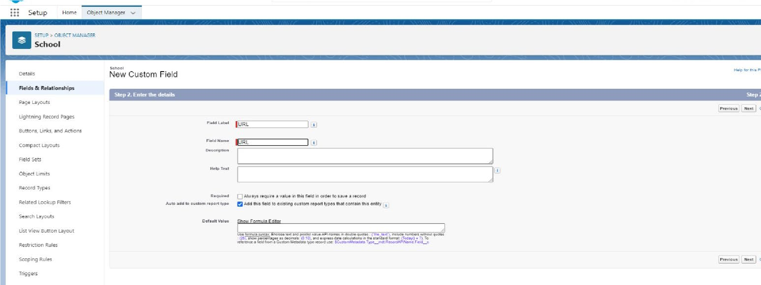

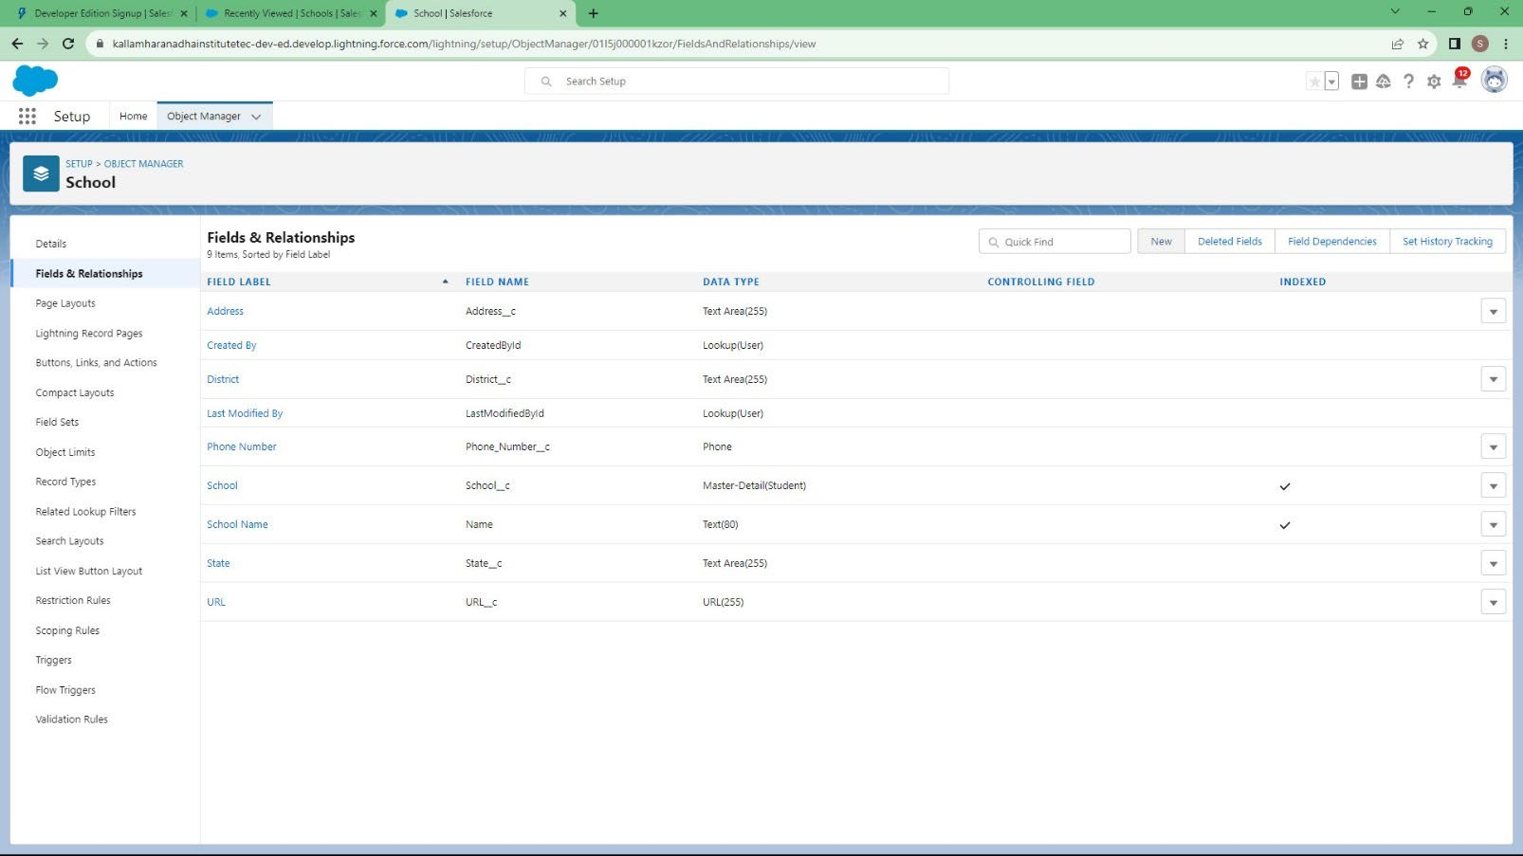

#### Creation Of Fields for The Student Objects

Note- Follow above steps 1 to 5 to create field and then follow below steps

1. Select the Phone as the Data Type, then click Next.
2. For Field Label, enter Phone Number.
3. Click Next, Next, then Save & New

**Let's create a master-detail relationship with School object**

Note- Follow above steps 1 to 5 to create field and then follow below steps

1. Select Master-Detail Relationship as the Data Type and click Next.
2. For Related to, enter School.
3. Click Next.
4. For Field Label, enter School.
5. Click Next, Next, Next and Save.

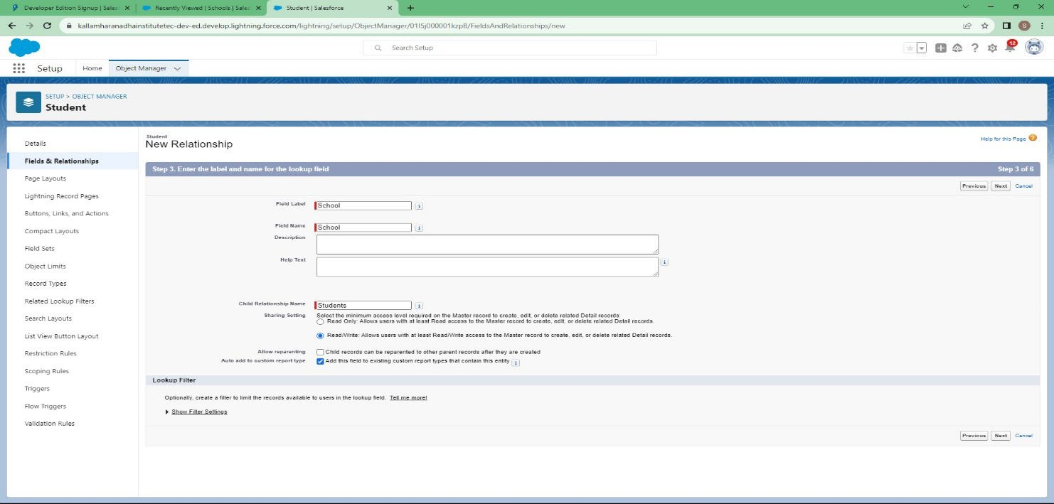

**Let’s create a Pick-List field:**

Note- Follow above steps 1 to 5 to create field and then follow below steps

1. From Setup, click Object Manager and select Student.
2. Click Fields & Relationships, then New.
3. Select Picklist as the Data Type and click Next.
4. For Field Label enter Results.
5. Select Enter values, with each value separated by a new line and enter these values:
6. Pass
7. Fail
8. Click Next, Next, then Save & New

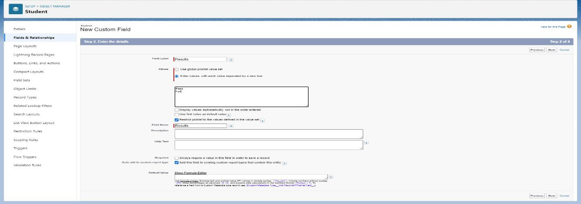

Let’s create a Number field:

Note- Follow above steps 1 to 5 to create field and then follow below steps

1. Select the Number as the Data Type, then click Next.
2. For Field Label, enter Class.
3. Click Next, Next, then Save & New
4. Follow steps 1 through 3 and create one more number field with Marks as the field labels.

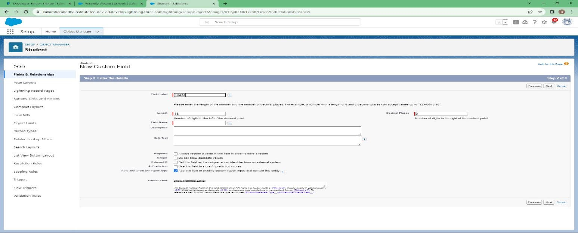

**Let’s create Roll-up summary fields on School Object to calculate the number of students**

1. Click gear icon Select Setup, This launches Setup in a new tab. 2. click Object Manager

1. Select School.
2. Click Fields & Relationships
3. Click New.
4. Select the Roll-up summary field as data type
5. Enter the field label as Number of students
6. Click Next
7. Then select the master object summarized as students
8. Select count as roll-up and then click Next, Next and save.

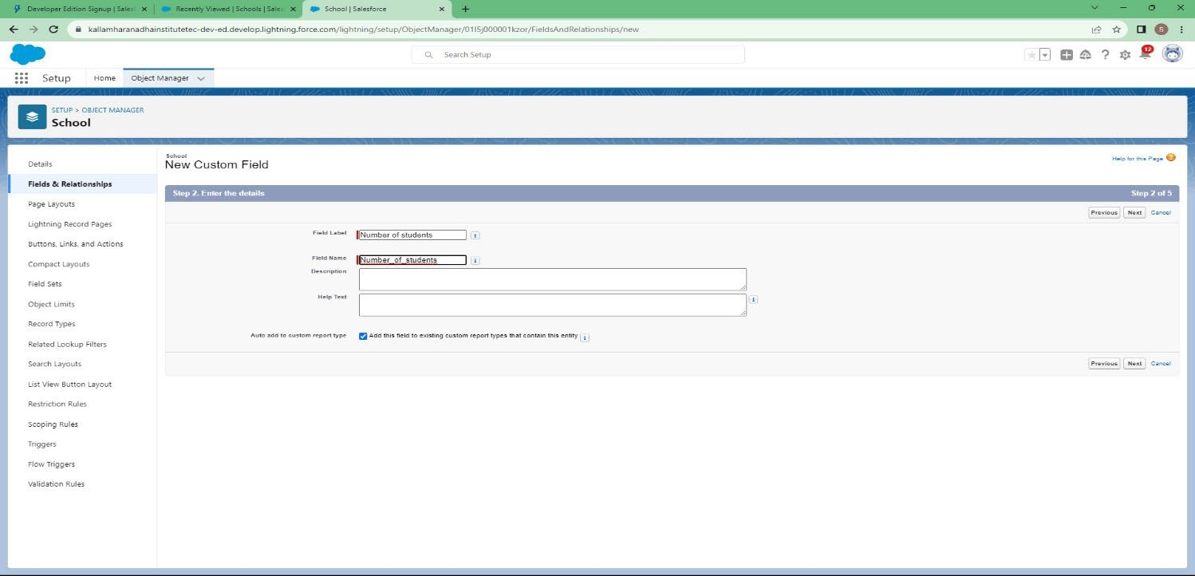

**Create one more rollup summary field-**

* From Setup, click Object Manager and select School.
* Click Fields & Relationships, then New.
* Select the Roll-up summary field as data type
* Enter the field label as Highest Marks
* Click Next
* Then select the master object summarized as students and then select Max as roll-up and then select Marks as field to aggregate.
* click Next, Next and save.

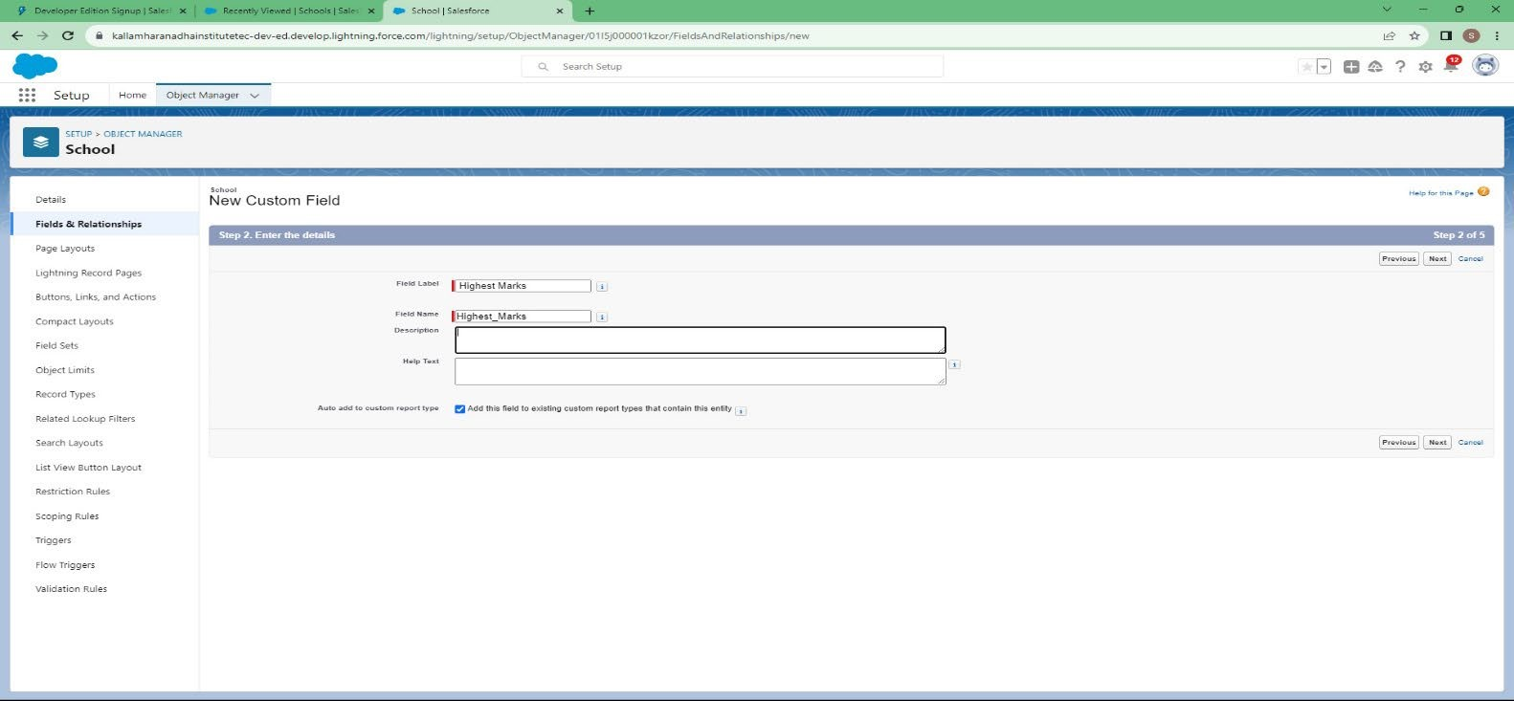

#### Creation Of Fields for the Parent Objects

* Select the Text Area as the Data Type, then click Next.
* For Field Label, enter Parent Address.
* Click Next, Next, then Save & New.
* Select the Phone as the Data Type, then click Next.
* For Field Label, enter Parent Number.
* Click Next, Next, then Save & New

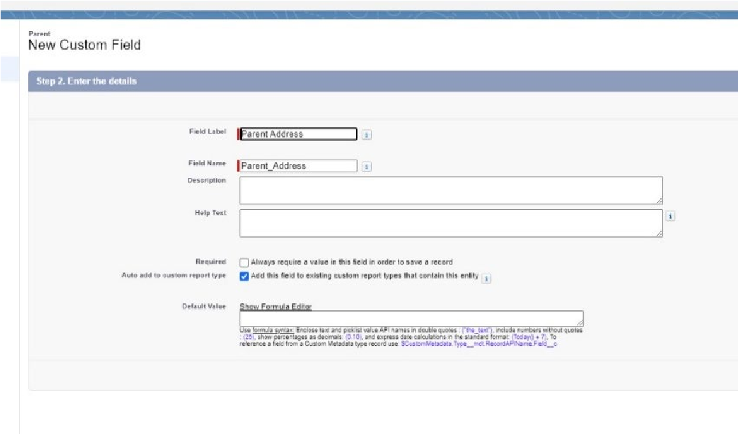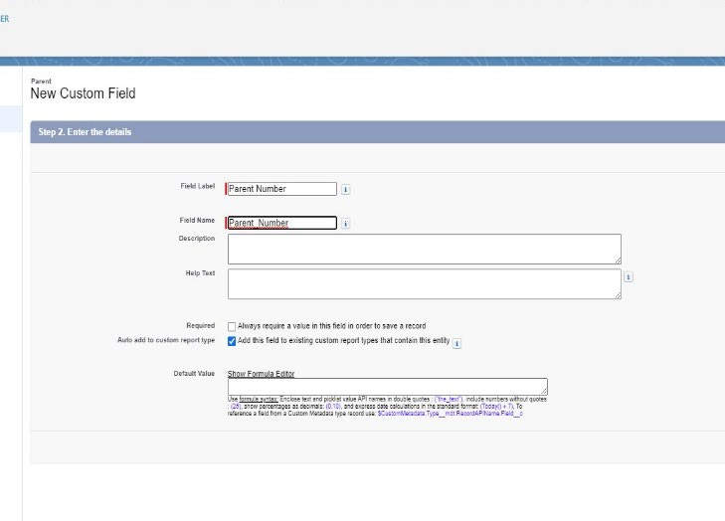

#### Profile

A profile is a group/collection of settings and permissions that define what a user can do in salesforce. A profile controls “Object permissions, Field permissions, User permissions, Tab settings, App settings, Apex class access, Visualforce page access, Page layouts, Record Types, Login hours & Login IP ranges

#### Creation On Profile

* From Setup enter Profiles in the Quick Find box
* Select Profiles.
* Click new, From the list of profiles, find Standard User (profile to clone) • For Profile Name, enter School Profile
* Click Save.
* While still on the school profile page, then click Edit.

Scroll down to Custom Object Permissions and Give view all access permissions

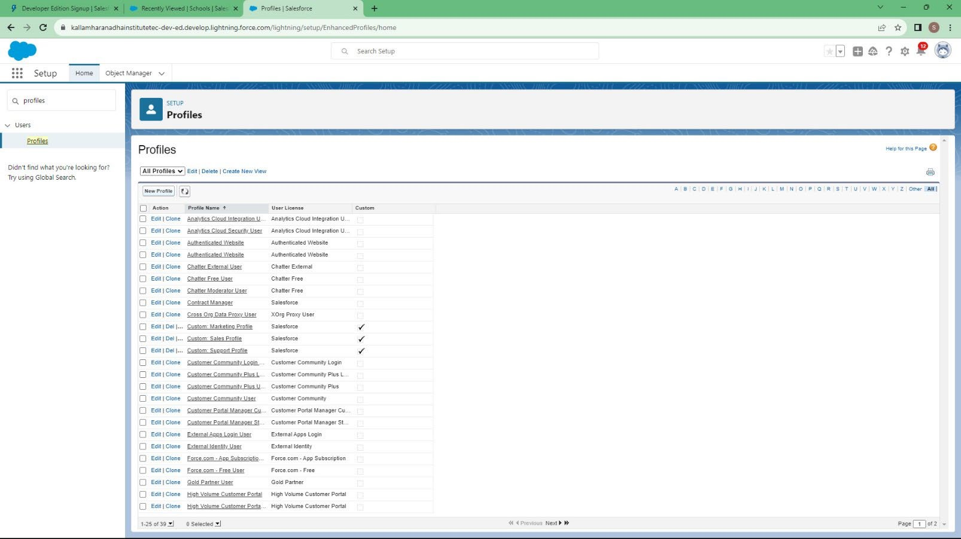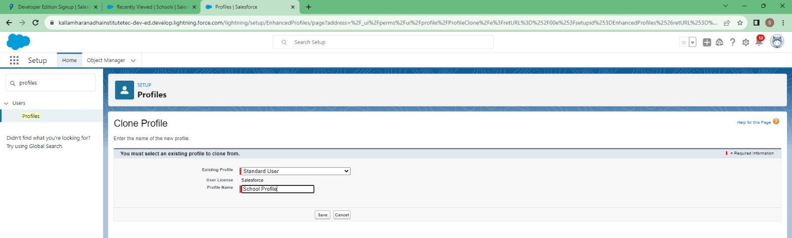

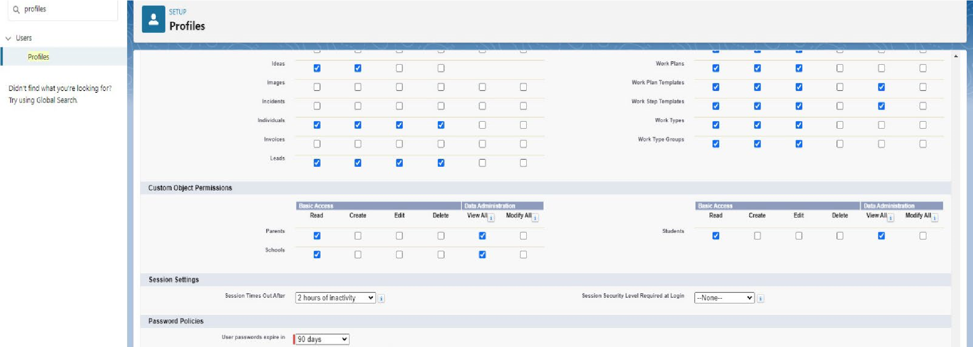

#### Users

A user is anyone who logs in to Salesforce. Users are employees at your company, such as sales reps, managers, and IT specialists, who need access to the company's records. Every user in Salesforce has a user account.

#### Creating A User

1. From Setup, in the Quick Find box, enter Users.
2. Select Users.
3. Click New User.
4. Enter the user’s name Parents and (Your) email address and a unique username in the form of an email address. By default, the username is the same as the email address.
5. Select a User License as salesforce.
6. NOTE- As Salesforce license can only be used by 2 Users at a time in Dev Org, so If you don’t find salesforce license then deactivate a user who has salesforce license or change the license type from Salesforce to any other.
7. Select a profile as a school profile.
8. Check Generate new password and notify the user immediately to have the user’s login name and a temporary password emailed to your email.
9. Similarly follow the above steps and create 2 users as Teachers and principals.

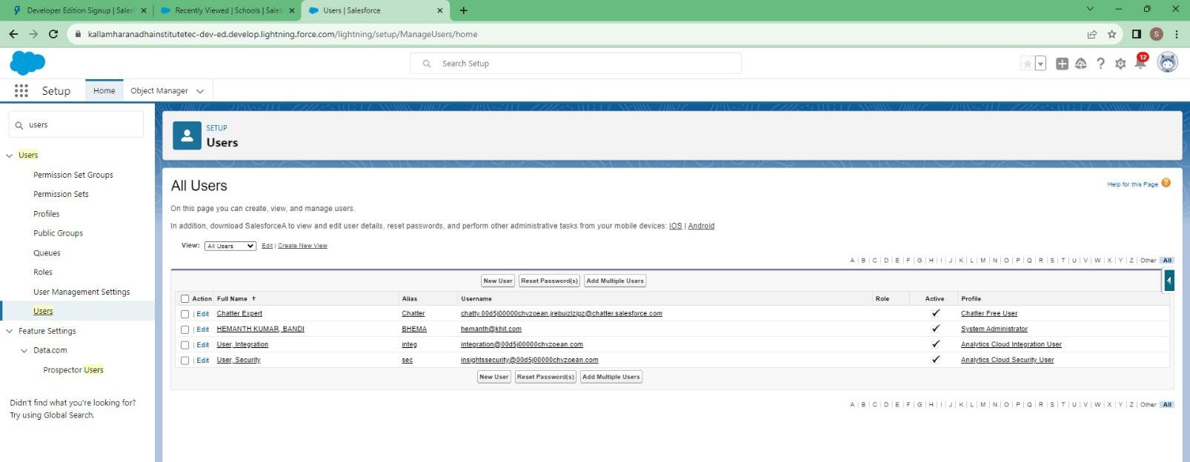 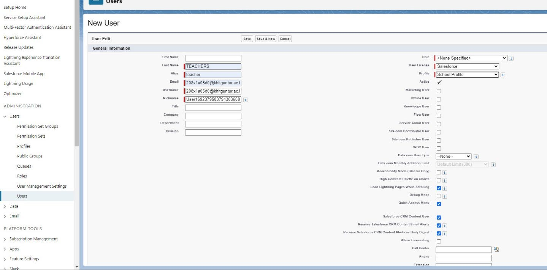

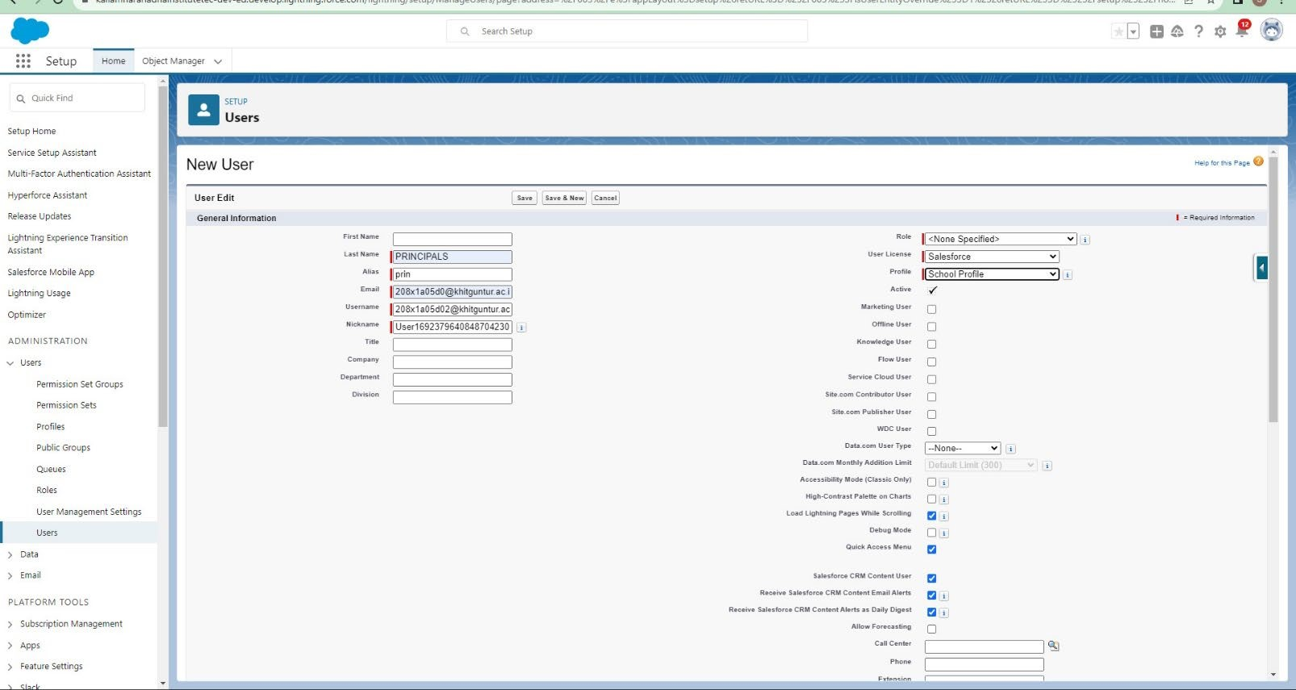

#### Permission Sets

A permission set is a collection of settings and permissions that give users access to various tools and functions. Permission sets extend users' functional access without changing their profiles.

#### Permission Sets 1

1. From Setup, enter Permission Sets in the Quick Find box, then select Permission Sets.
2. Click New.
3. Give the name of the Permission set name as teacher permission.
4. Under the object settings give the view create and edit permissions to all 3 custom objects (By click open the object)
5. Click on manage assignment
6. Click on add assignment.
7. Click on Teacher (user), Next, Assign.

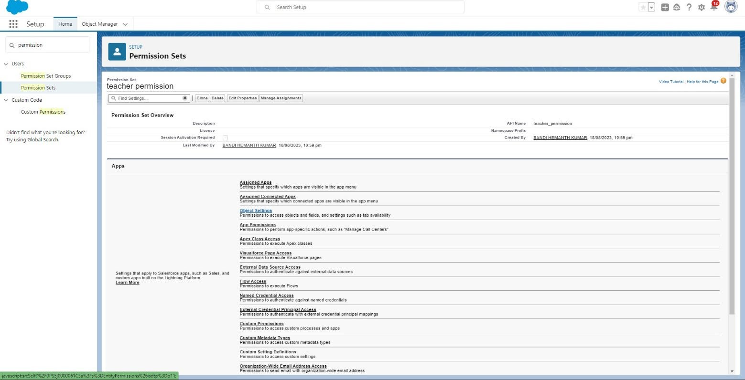

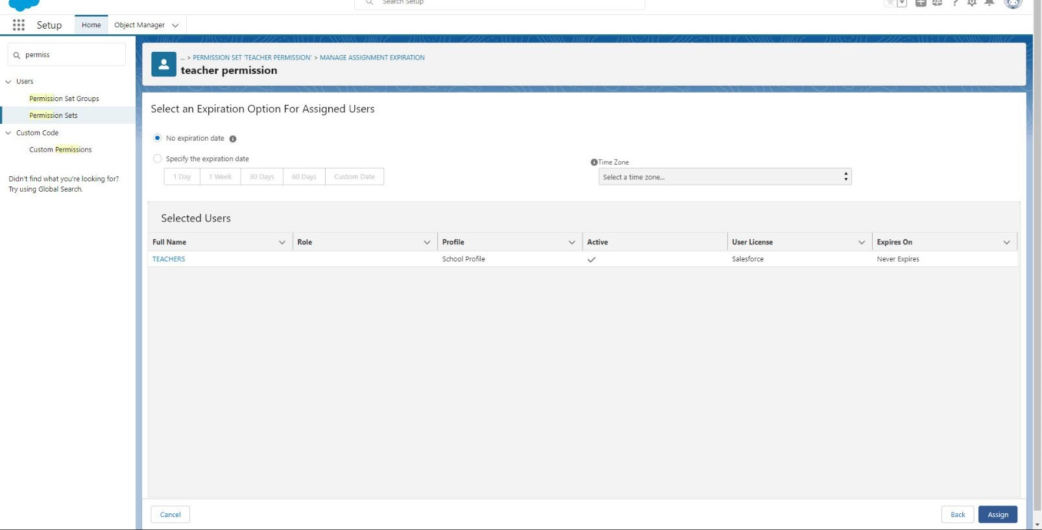

Similarly, follow the above steps for the permission set 2.

#### Permission Sets 2

1. From Setup, enter Permission Sets in the Quick Find box, then select Permission Sets.
2. Click New.
3. Give the name of the Permission set name as Principal permission and then under the object settings give all permissions for the all 3 custom objects and assign them to the principal user.

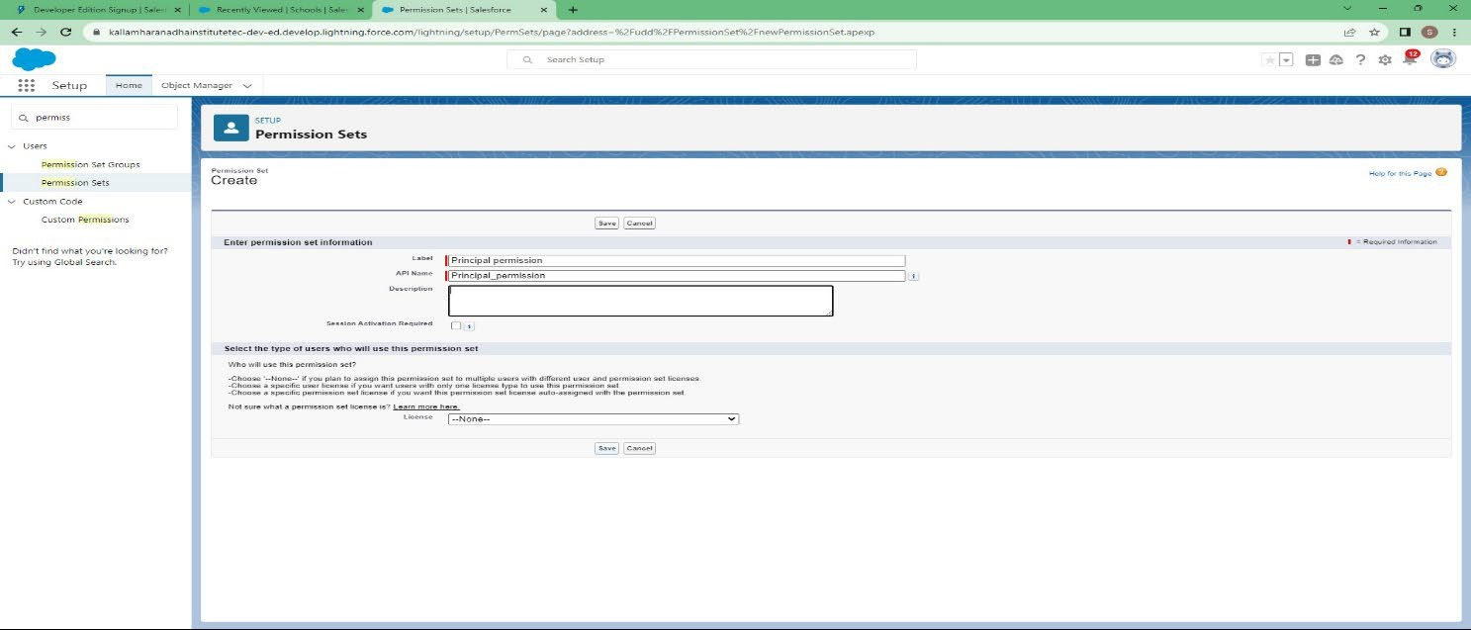

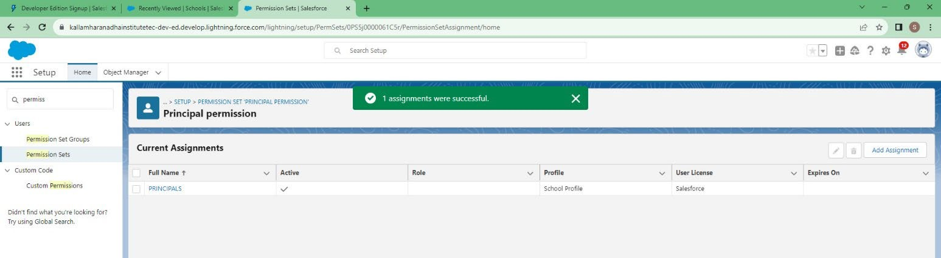

**User Adoption**

#### Create Record (School)

1. Click on App Launcher on left side of screen.
2. Search School Management App & click on it.
3. Click on Schools tab.
4. Click new button
5. Fill all School record details.
6. Click on Save Button

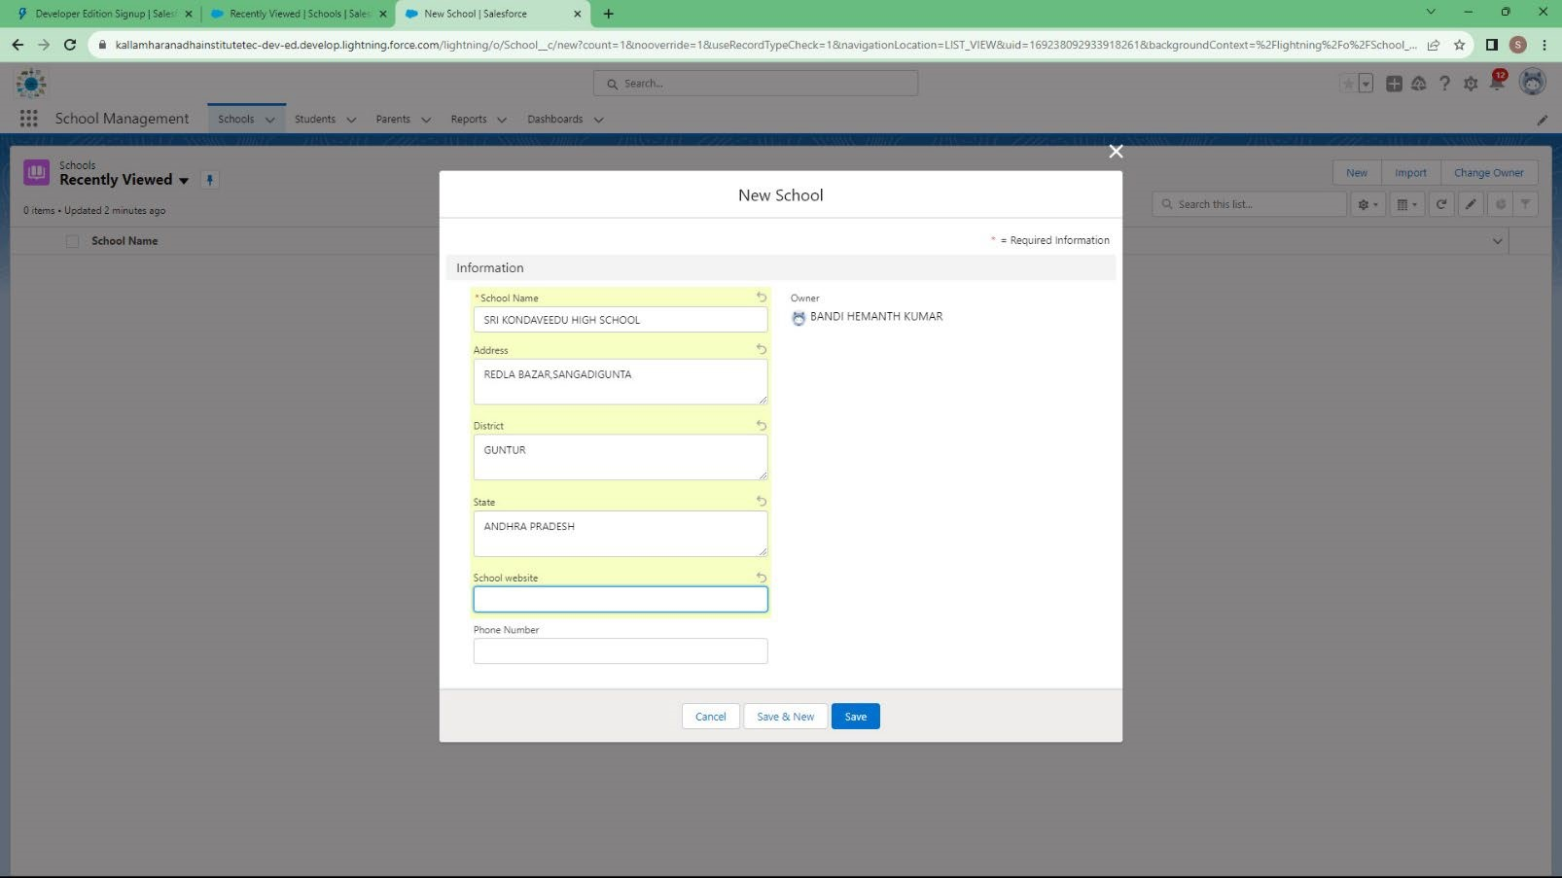

#### View Record (School)

1. Click on App Launcher on left side of screen.
2. Search School Management App & click on it.
3. Click on Schools Tab.
4. Click on any record name. you can see the details of the school.

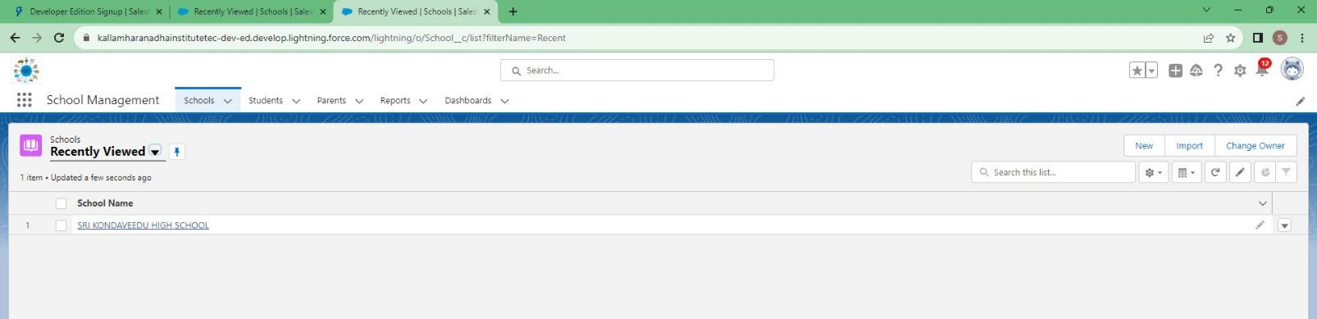

#### Delete Record (School)

1. Click on App Launcher on left side of screen.
2. Search School Management App & click on it.
3. Click on Schools Tab.
4. Click on Arrow at right hand side on that Particular record.
5. Click delete and delete again.

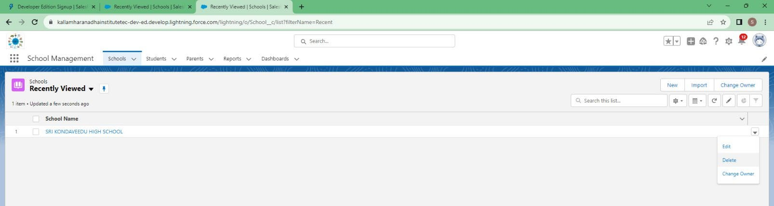

#### Reports

Reports in Salesforce is a list of records that meet a particular criterion which gives an answer to a particular question. These records are displayed as a table that can be filtered or grouped based on any field.

**There are 4 types of report formats in Salesforce:**

1. **Tabular Reports:**

This is the most basic report format. It just displays the row of records in a table with a grand total. While easy to set up they can’t be used to create groups of data or charts and also cannot be used in Dashboards. They are mainly used to generate a simple list or a list with a grand total.

1. **Summary Reports:**

It is the most commonly used type of report. It allows grouping of rows of data, view subtotal, and create charts.

1. **Matrix Reports:**

It is the most complex report format. Matrix report summarizes information in a grid format. It allows records to be grouped by both columns and rows. It can also be used to generate dashboards. Charts can be added to this type of report.

**4.Joined Reports:**

These types of reports let us create different views of data from multiple report types. The data is joined reports are organized in blocks. Each block acts as a sub report with its own fields, columns, sorting, and filtering. They are used to group and show data from multiple report types in different views.

**Report types:**

Report type determines which set of records will be available in a report. Every report is based on a particular report type. The report type is selected first when we create a report. Every report type has a primary object and one or more related objects. All these objects must be linked together either directly or indirectly.

A report type cannot include more than 4 objects.

Once a report is created its report type cannot be changed.

**There are 2 types of report types:**

1. **Standard Report Type:**

Standard Report Types are automatically included with standard objects and also with custom objects where “Allow Reports” is checked.

Standard report types cannot be customized and automatically include standard and custom fields for each object within the report type. Standard report types get created when an object is created, also when a relationship is created.

Note: Standard report types always have inner joins.

1. **Custom Report Types:**

Custom report types are reporting templates created to streamline the reporting process. Custom Reports are created by an administrator or User with “Manage Custom Report Types” permission.

Custom report types are created when standard report types cannot specify which records will be available on reports. In custom report types we can specify objects which will be available in a particular report. The primary object must have a relationship with other objects present in a report type either directly or indirectly.

**There are 3 types of access levels of folders:**

1. **Viewer:**

With this access level, users can see the data in a report but cannot make any changes except cloning it into a new report.

1. **Editor:**

With this access level, users can view and modify the reports it contains and can also move them to/from any other folders they have access level as Editor or Manager.

1. **Manager:**

With this access level, users can do everything Viewers & Editors can do, plus they can also control other user’s access levels to this folder. Also, users with Manager Access levels can delete the report.

From this milestone we are going to import the data and create the reports and dashboards for data visualization in the application.

#### Create Report

**Reports:**

In School Management App click Reports tab.

1. Click New Report.
2. Select the report type as School with students and parents for the report.
3. Click start report.
4. Customize your report, then save and run
5. Give report name – Schools with Students Report
6. Click Save

NOTE: In this report you can see your all record of the object you selected for reporting (What you Selects in “Select a report type option”).

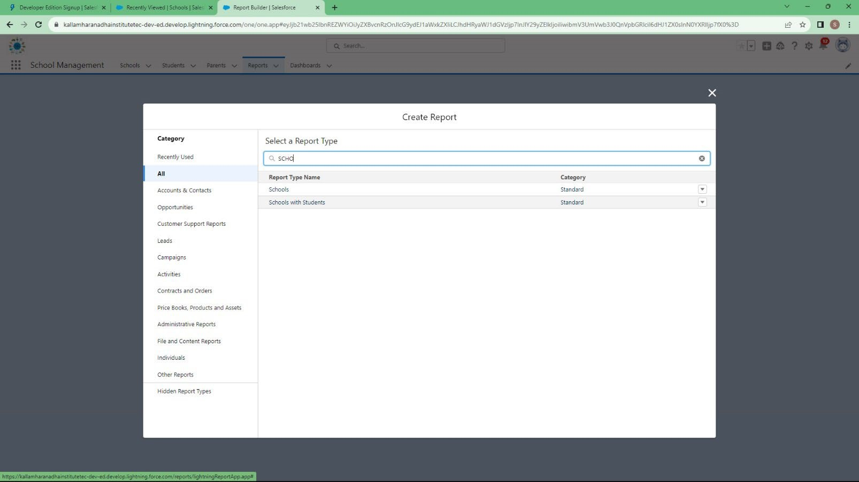

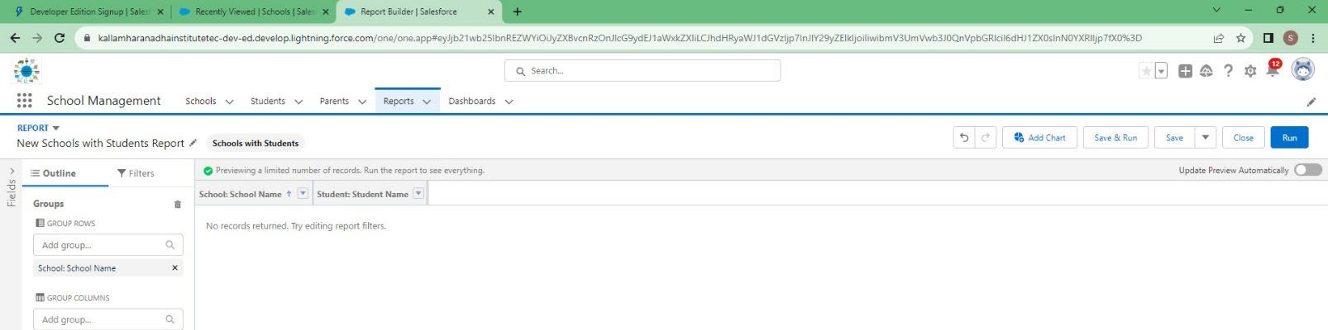

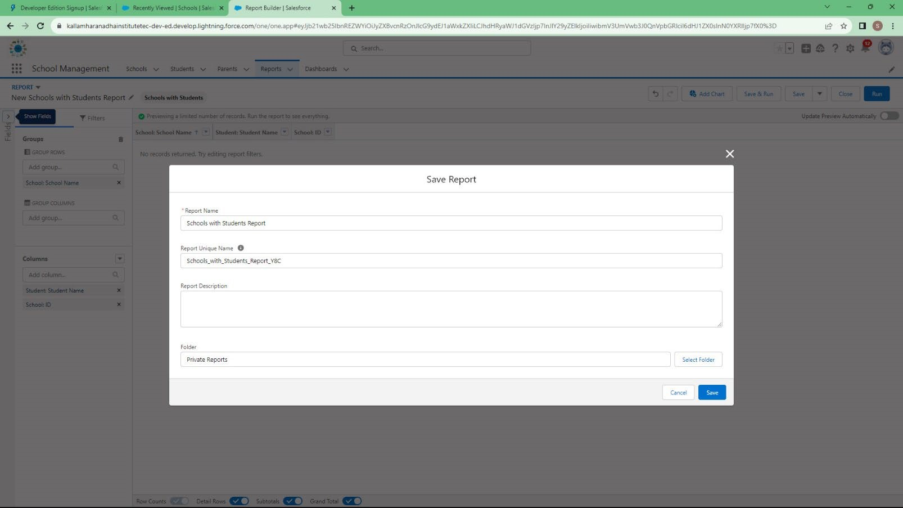

#### View Report

1. Click on App Launcher on left side of screen.
2. Search School Management App & click on it.
3. Click on Reports Tab.
4. Click on School with Students report and see records

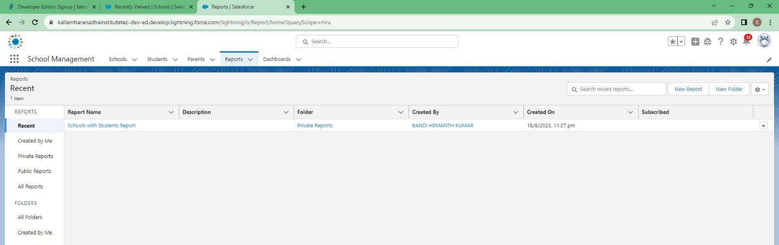

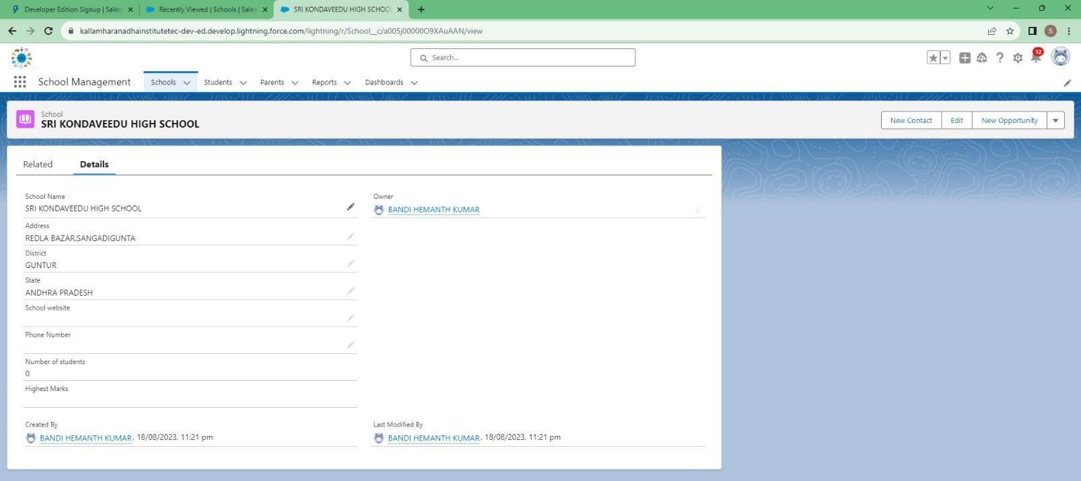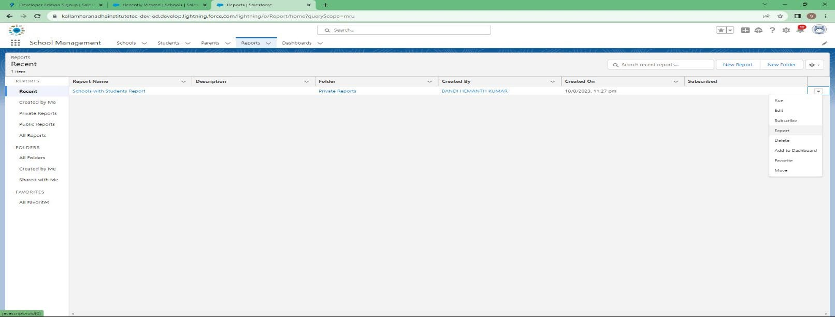

**Advantages:**

* Saves Time & Resources
* Improves Communication
* Better Efficiency
* Better Student Data Management
* Quick Access to Every Information
* Expense Management

**Disadvantages:**

* There are no such disadvantages of school management software but there are some issues that are commonly faced by users.
* The school management software does not have enough features to fulfill the school’s requirements

There are countless advantages of the school management system, and one can’t simply ignore these benefits to save a few bucks.

**APPLICATIONS:**

The application can be used by a variety of educational institutions, including:

* Schools and K-12 institutions
* Colleges and universities
* Online learning platforms
* Tutoring centers and coaching institutes
* Non-profit educational initiatives
* Training and development programs
* Vocational institutes
* Special education programs
* After-school programs
* Language schools

The application has the potential to revolutionize the way schools are run. By automating administrative tasks and improving communication, the application can help schools to provide a better educational experience for their students.

In the future, the application could be extended to include new features and functionality, such as:

* A mobile app for teachers and parents.
* A data analytics dashboard for administrators.
* Integration with other educational systems, such as learning management systems and student information systems.

### Conclusion

* School management software provides a way for schools to track student progress and hold students, teachers, and administrators accountable for their performance.
* This helps to ensure that all stakeholders are committed to achieving academic success.
* In conclusion, school management software is an essential tool for educational institutions. It helps to streamline administrative tasks, improve communication, and enhance overall efficiency.
* By using school management software, schools can improve student outcomes and provide a better education for their students.

### Future Scope

* The use of software for school management will ensure that schools in the future have streamlined processes in the apps with built-in features that allow for operational effectiveness, automatic upgrades and uniform compliance.
* Streaming of the process will include calibration that works for all departments and for all the users across the levels. This will ensure that redundant data entry work is eliminated along with any with unnecessary subsystems and processes that complicate administrative work in institutions
* Thus, for a successful school management software, it is essential that organisation consider a mobile app that can be easily accessed by students, teacher, parents and school staff alike.
* The application can be integrated with other systems, such as learning management systems and student information systems, to make it easier for students to learn and for teachers to manage their classes.
* The application can be used to collect data on student behavior and performance, which can then be used to improve teaching and learning.
* Gamification and rewards can be used to motivate students to learn and achieve their goals.
* Virtual reality and augmented reality can be used to create immersive learning experiences.
* Predictive analytics can be used to identify students who are at risk of failing and provide them with additional support.

# THANK YOU